**UML DIAGRAMS**

UML stands for Unified Modelling Language. UML is a standardized general-purpose modelling language in the field of object-oriented software engineering. The standard is managed, and was created by, the Object Management Group.

The goal is for UML to become a common language for creating models of object-oriented computer software. In its current form UML is comprised of two major components: a Meta-model and a notation. In the future, some form of method or process may also be added to; or associated with, UML.

The Unified Modelling Language is a standard language for specifying, Visualization, Constructing and documenting the artefacts of software system, as well as for business modelling and other non-software systems.

The UML represents a collection of best engineering practices that have proven successful in the modelling of large and complex systems.

The UML is a very important part of developing objects-oriented software and the software development process. The UML uses mostly graphical notations to express the design of software projects.

**GOALS:**

The Primary goals in the design of the UML are as follows:

1. Provide users a ready-to-use, expressive visual modelling Language so that they can develop and exchange meaningful models.
2. Provide extendibility and specialization mechanisms to extend the core concepts.
3. Be independent of particular programming languages and development process.
4. Provide a formal basis for understanding the modelling language.
5. Encourage the growth of OO tools market.
6. Support higher level development concepts such as collaborations, frameworks, patterns and components.
7. Integrate best practices.

**USE CASE DIAGRAM**

* A use case diagram in the Unified Modeling Language (UML) is a type of behavioral diagram defined by and created from a Use-case analysis.
* Its purpose is to present a graphical overview of the functionality provided by a system in terms of actors, their goals (represented as use cases), and any dependencies between those use cases.
* The main purpose of a use case diagram is to show what system functions are performed for which actor. Roles of the actors in the system can be depicted.

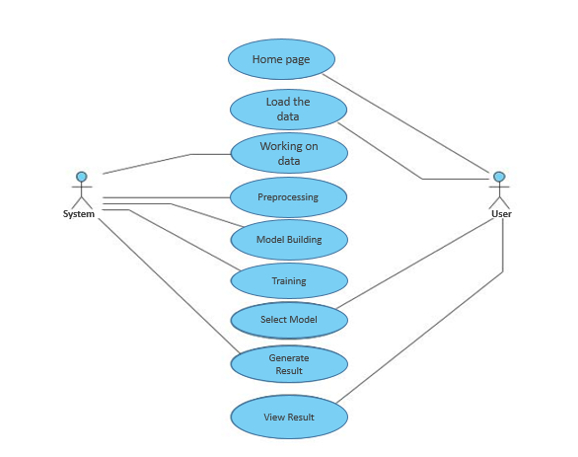

**CLASS DIAGRAM**

In software engineering, a class diagram in the Unified Modeling Language (UML) is a type of static structure diagram that describes the structure of a system by showing the system's classes, their attributes, operations (or methods), and the relationships among the classes. It explains which class contains information

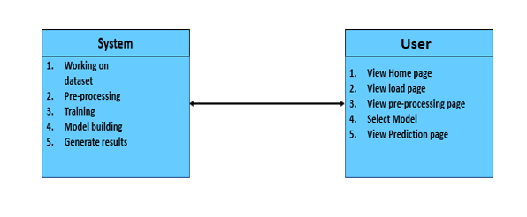

**SEQUENCE DIAGRAM**

* A sequence diagram in Unified Modeling Language (UML) is a kind of interaction diagram that shows how processes operate with one another and in what order.
* It is a construct of a Message Sequence Chart. Sequence diagrams are sometimes called event diagrams, event scenarios, and timing diagrams

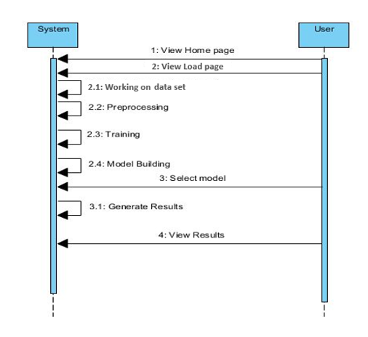

**COLLABORATION DIAGRAM:**

In collaboration diagram the method call sequence is indicated by some numbering technique as shown below. The number indicates how the methods are called one after another. We have taken the same order management system to describe the collaboration diagram. The method calls are similar to that of a sequence diagram. But the difference is that the sequence diagram does not describe the object organization whereas the collaboration diagram shows the object organization.

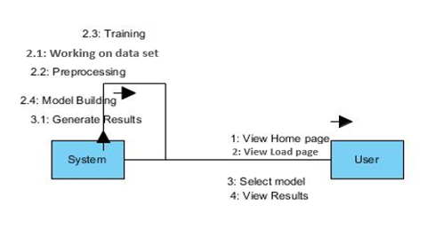

**DEPLOYMENT DIAGRAM**

Deployment diagram represents the deployment view of a system. It is related to the component diagram. Because the components are deployed using the deployment diagrams. A deployment diagram consists of nodes. Nodes are nothing but physical hardware’s used to deploy the application.

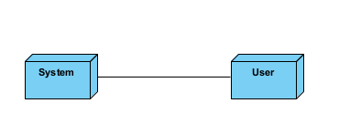

**ACTIVITY DIAGRAM:**

Activity diagrams are graphical representations of workflows of stepwise activities and actions with support for choice, iteration and concurrency. In the Unified Modelling Language, activity diagrams can be used to describe the business and operational step-by-step workflows of components in a system. An activity diagram shows the overall flow of control.

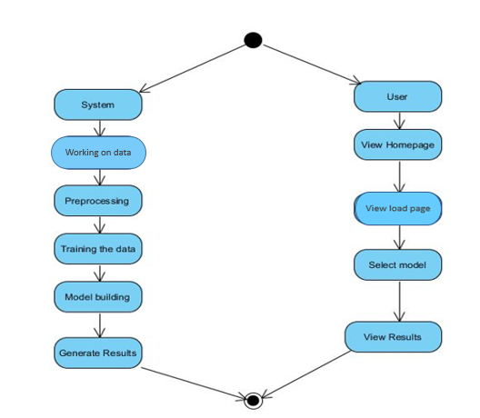

**COMPONENT DIAGRAM**:

A component diagram, also known as a UML component diagram, describes the organization and wiring of the physical **c**omponents in a system. Component diagrams are often drawn to help model implementation details and double-check that every aspect of the system's required function is covered by planned development.

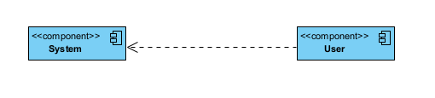

**ER DIAGRAM:**

An Entity–relationship model (ER model) describes the structure of a database with the help of a diagram, which is known as Entity Relationship Diagram (ER Diagram). An ER model is a design or blueprint of a database that can later be implemented as a database. The main components of E-R model are: entity set and relationship set.

An ER diagram shows the relationship among entity sets. An entity set is a group of similar entities and these entities can have attributes. In terms of DBMS, an entity is a table or attribute of a table in database, so by showing relationship among tables and their attributes, ER diagram shows the complete logical structure of a database. Let’s have a look at a simple ER diagram to understand this concept.

# 

**DFD DIAGRAM:**

A Data Flow Diagram (DFD) is a traditional way to visualize the information flows within a system. A neat and clear DFD can depict a good amount of the system requirements graphically. It can be manual, automated, or a combination of both. It shows how information enters and leaves the system, what changes the information and where information is stored. The purpose of a DFD is to show the scope and boundaries of a system as a whole. It may be used as a communications tool between a systems analyst and any person who plays a part in the system that acts as the starting point for redesigning a system.

